**Course Name (CMPS-480)**

**Spring 2021**

**T 6:50-10:00 pm**

**Project #: Assignment 4**

**Title: Rogue Fitness**

**Due Date: ?**

**Grade:**

**e-mail: marlene.zeledon@laverne.edu Submitted by Marlene Boyce 21**

**major: Computer Science concentration: Internet Programming**

|  |  |  |  |  |  |  |  |
| --- | --- | --- | --- | --- | --- | --- | --- |
| **Y**  **I=**    **N** | **Description – 10%**  **Incomplete** | **Y**  **I**    **N** | **Design – 15%**  **UML and flowchart; pseudocode - if asked** | **Y**  **I**    **N** | **Code – 50%**  highlight and comments piece of the code which you had to **add** or **modify (worth 10 %)** | **Y**  **I**    **N** | **Test – 25%**  **Test plan**  **(4 test cases – include boundary testing) with screenshot results** |

|  |  |  |  |  |  |  |  |
| --- | --- | --- | --- | --- | --- | --- | --- |
| **Y**  **I=**    **N** | **Description –10%**  **Incomplete** | **Y**  **I**    **N** | **Design – 15%**  **UML and flowchart; pseudocode - if asked** | **Y**  **I**    **N** | **Code – 50%**  highlight and comments piece of the code which you had to **add** or **modify (worth 10 %)** | **Y**  **I**    **N** | **Test – 25%**  **Test plan (4 test cases – include boundary testing) with screenshot results** |

**Submitted to**

**Prof. Jozef Goetz**

**University of La Verne, La Verne**

**C# project - Uploaded**

**Comments on your C# source code**

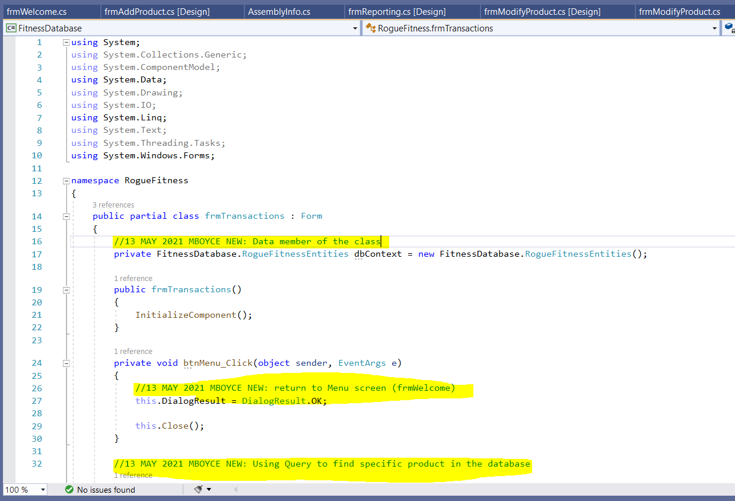

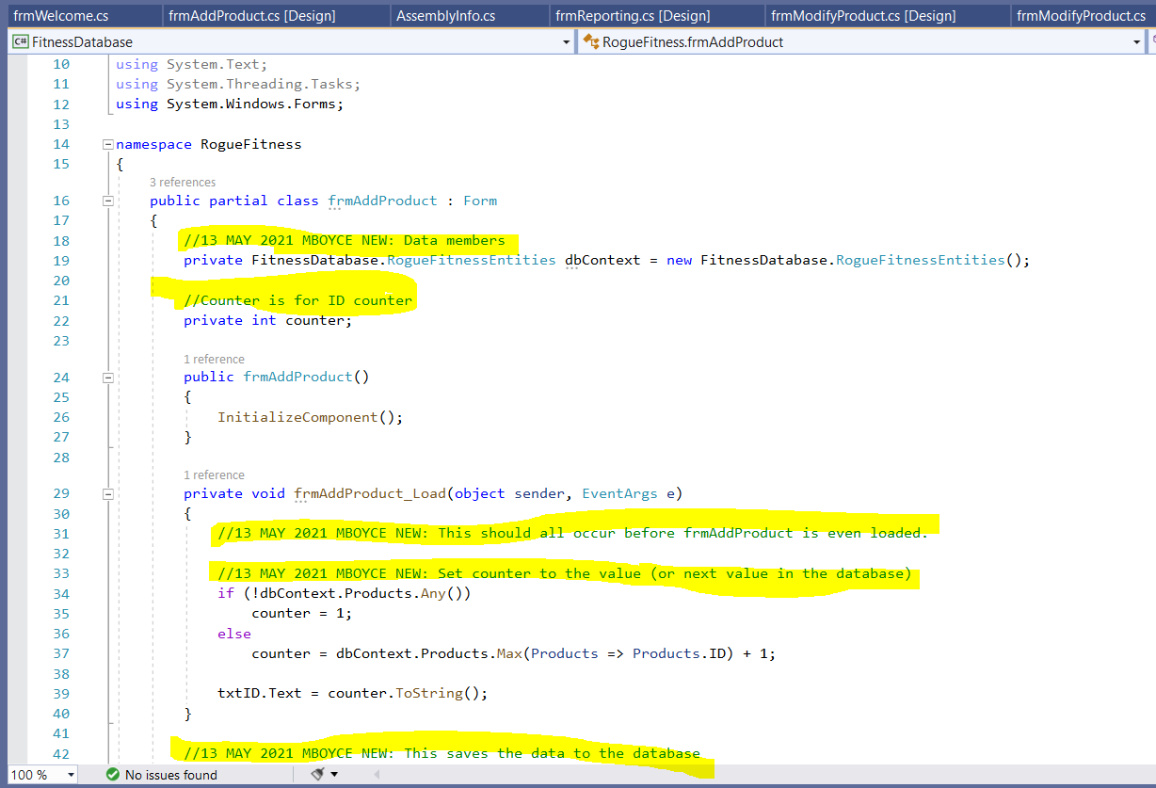

**UML Diagram**

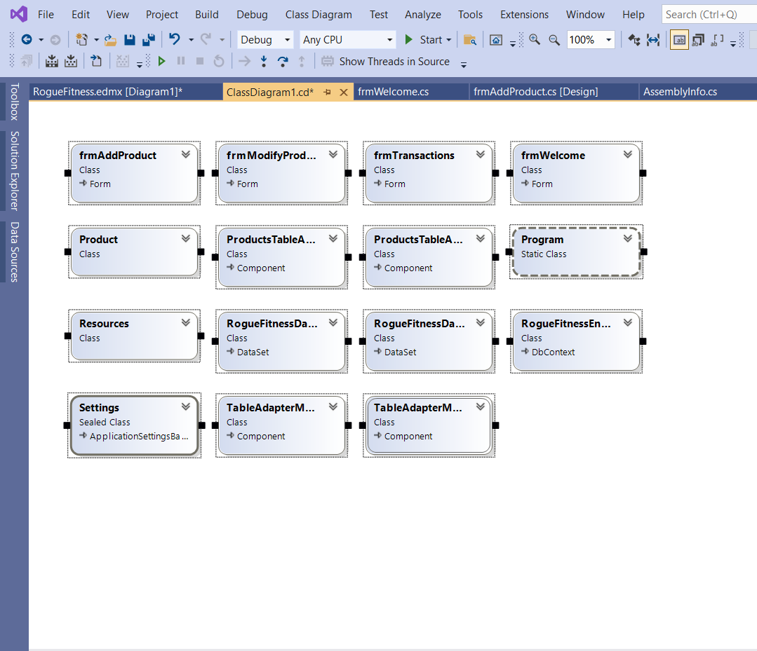

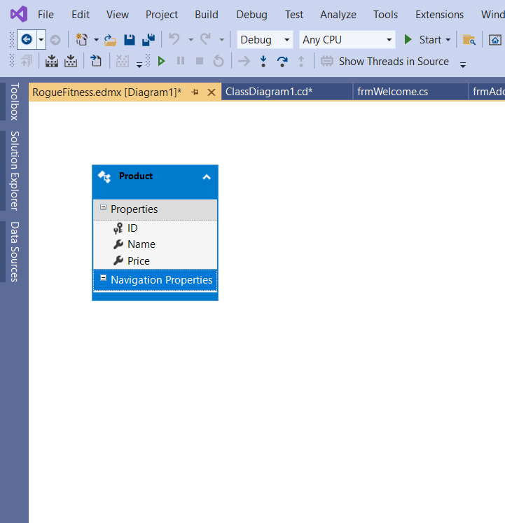

**Your output**

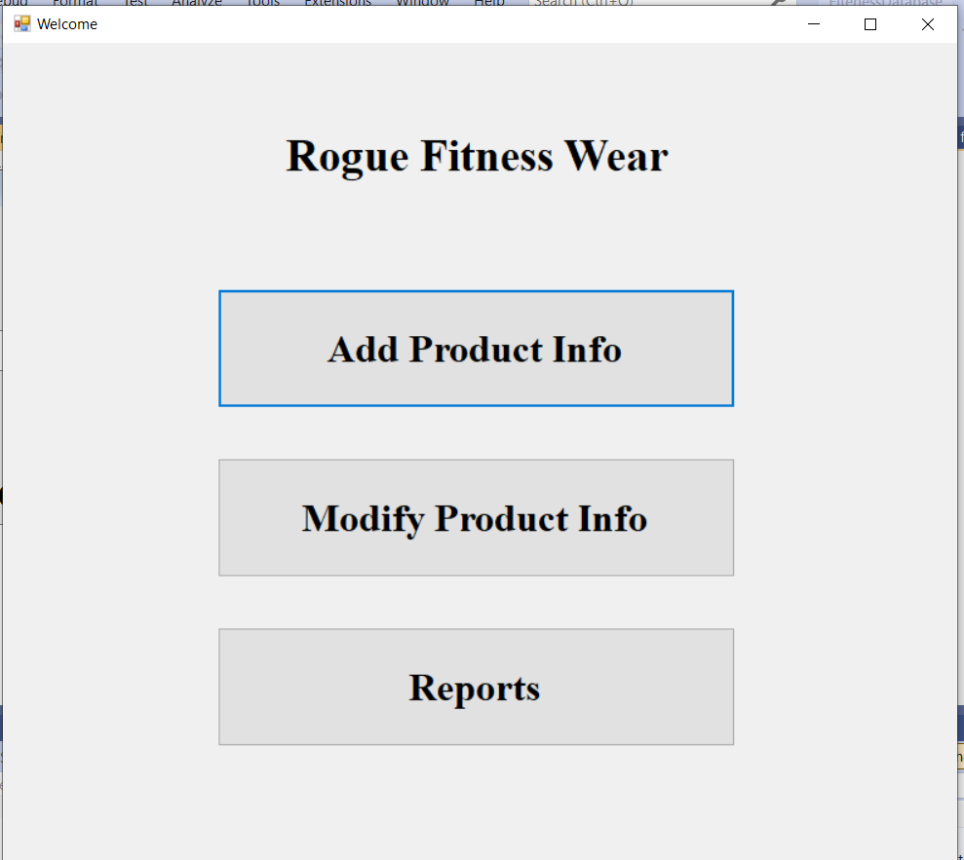

**Entering the 3rd product**

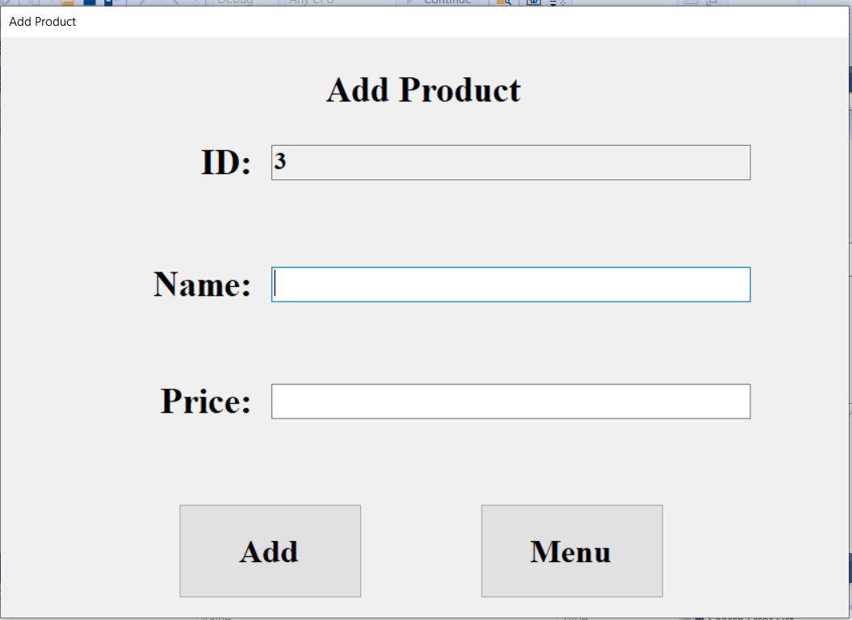

**Kettlebell was added, and product was saved**

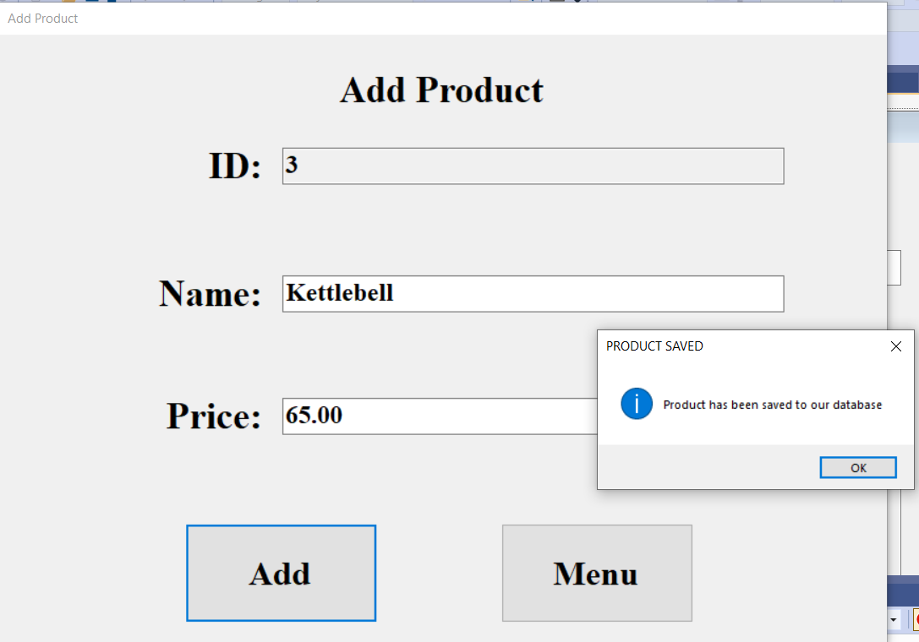

**Then I went back to menu, and clicked modified product**

**Product 1**

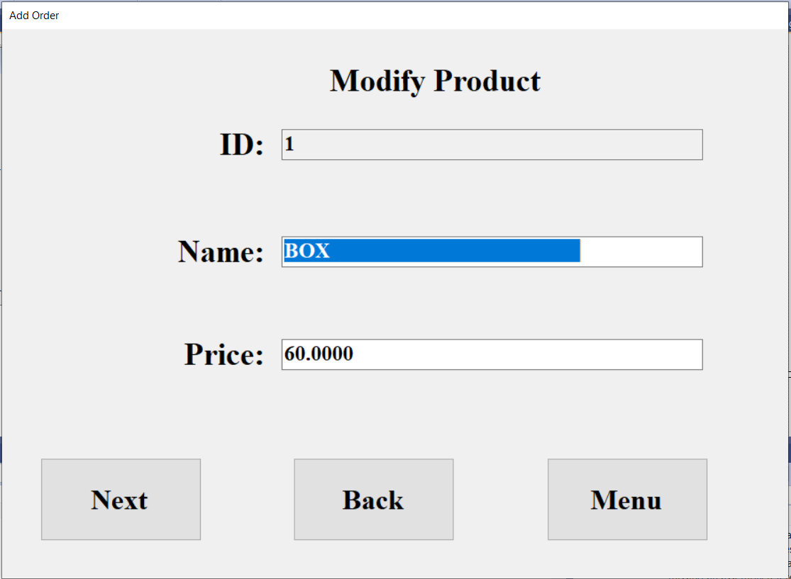

**Product 2**

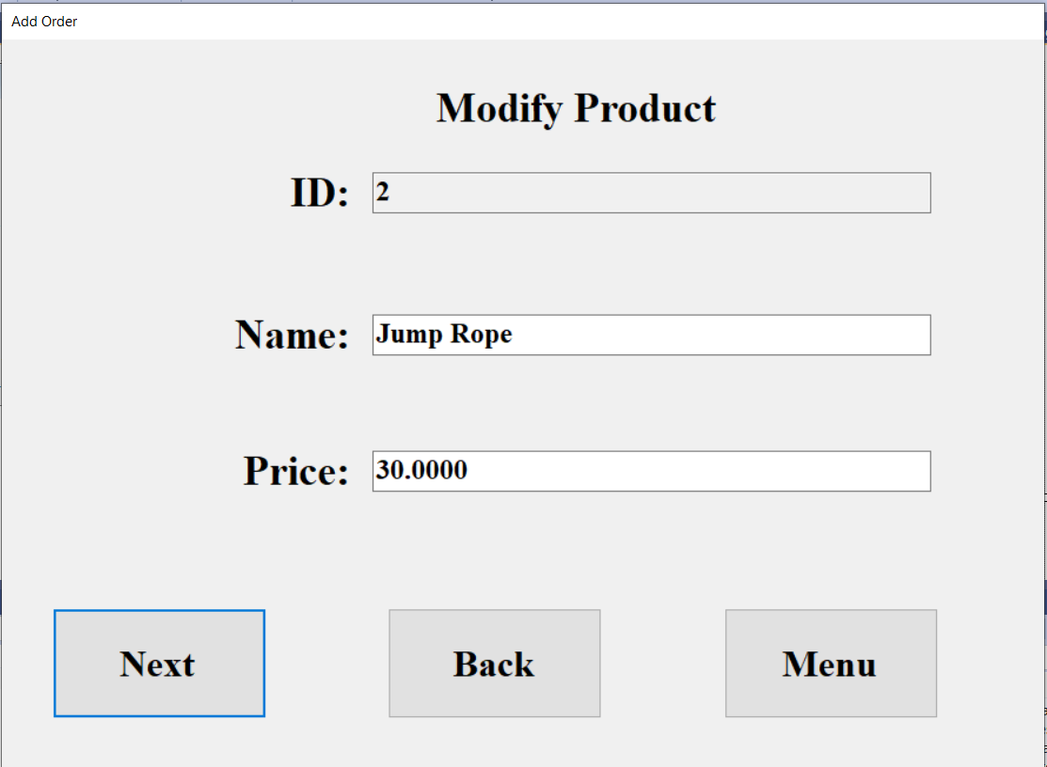

**Product 3**

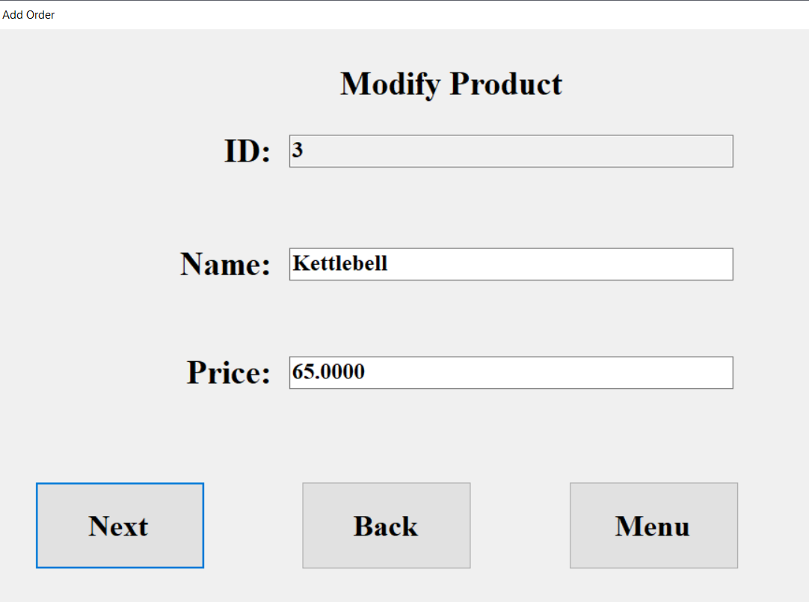

**Then I clicked menu and went to reporting:**

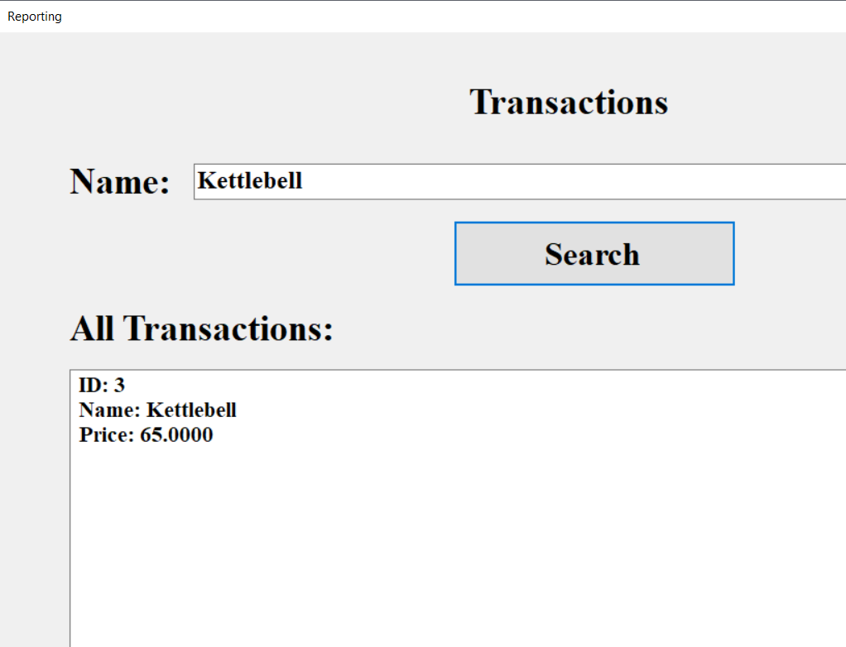

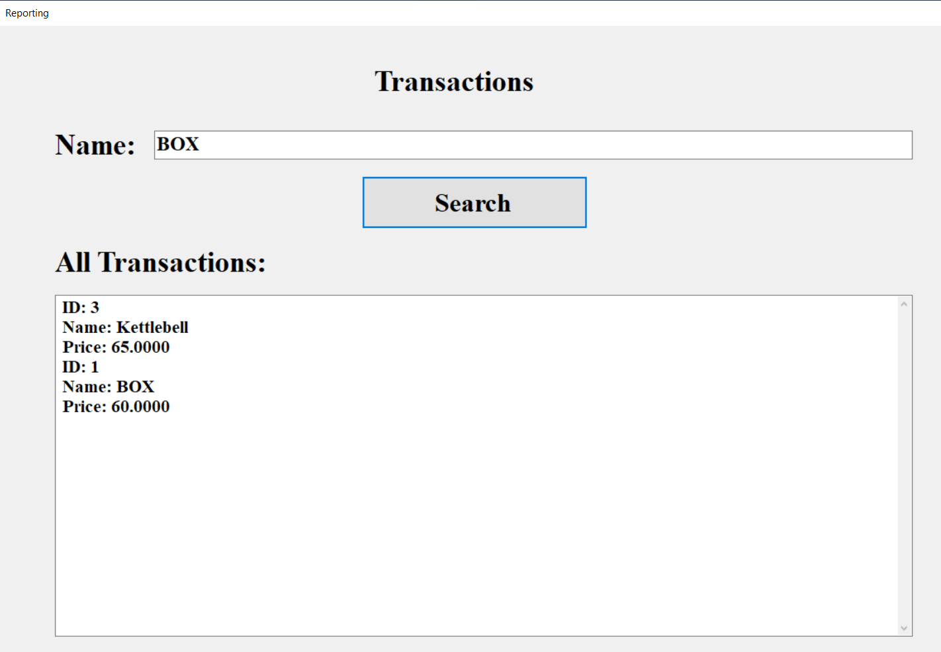

**SQL SERVER:**

